**INTO the Unknown**



**Session 2023 - 2027**

**Submitted by:**

Muhammad Omer 2023-CS-68

**Supervised by:**

Muhammad Awais

**Course:**

CSC-102 Programming Fundamentals

Department of Computer Science

**University of Engineering and Technology**

**Lahore Pakistan**

**Here you can find the major parts of your Proposal documentation**

* **Short Description of your project**

I wanted to create a game that is fun to play.I had this idea a two to three years backs and now I finally have the skills to fulfill my project plans.In this game u play as a ship lost in space and your goal is to survive as long as possible. You need to collect space energy to charge your cannons, dodge meteors, use your cannon to break through blockades.

* **Game Characters Description**

1. Ship :- this is u the player.
2. Meterors :- These are space rocks moving towards u. You must dodge them or ship will get destroyed.
3. Moon :- These are large space bodies
4. Blockades:- These are here to stop u from moving and u can destroy them by shooting.

* **Game Objects Description**

1. Space energy:- U can collect this energy to charge your cannons.
2. Laser residue:- U can also collect the residue left by your lasers to charge them up again.

* **Rules** 
  1. Survive for as long as possible
  2. Dodge all rocks
  3. Try to collect all space energy
  4. Try to survive
* **Goal of the Game**

Survive For Long as possible.

* **Wireframes**

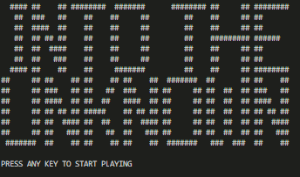

**Figure 1: Start Screen**

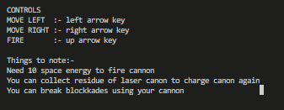

**Figure 2: Controls menu**

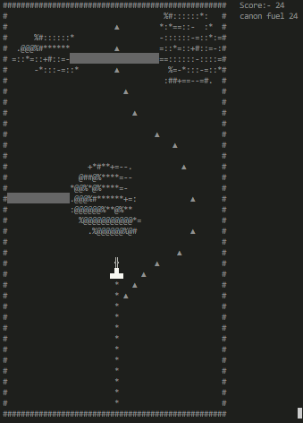

**Figure 3: Game Play**

**Data Structures (Parallel Arrays)**

char screen[screen_h][screen_l]

char buffer[screen_h][screen_l]

char Gameover_screen[screen_h][screen_l]

char randArrays[3][screen_h][screen_l]

* **Function Prototypes**

int random_function(int total_options);

void cursor_hide();

void clearConsole();

void gotoxy(int x, int y);

void print_border();

void print_Array(char screen[screen_h][screen_l]);

void moveDown(char screen[screen_h][screen_l], char buffer[screen_h][screen_l], char randArrays[3][screen_h][screen_l]);

void printheader();

void erase_player(char screen[screen_h][screen_l]);

void print_player(char screen[screen_h][screen_l]);

void move_player(char screen[screen_h][screen_l], int direction,bool input);

void check_player_input(char screen[screen_h][screen_l]);

void player_visuals();

char checkCollision(char screen[screen_h][screen_l], int x, int y);

bool scoreCollision(char screen[screen_h][screen_l], int x, int y);

void fire_laser(char screen[screen_h][screen_l], int& laserY, bool& laserActive);

void move_laser(char screen[screen_h][screen_l], int& laserY, bool& laserActive);